Assignment
Fundamental Theory
(LAB: 12)
NAME: Majid Ali
CMS ID: 053-25-0017
PROGRAM: Software engineering (Section: A)

Q 1:
- Write a C++ program that maintain record of students. Student contains following details:
- a) ID
- b) Name
- c) Department
- d) Email
- e) Phone number
Create a structure names Student. Ask the user to enter record for 5 students and store those details in variables of Student type. Finally, print those records on screen
#include <iostream>
using namespace std;
struct student{
string ID;
string name;
string depart;
string email;
string phonenumber;
};
int main(){
student p;
cout<<"Enter the ID: ";
cin>>p.ID;
cout<<"Enter the name: ";
cin.ignore();
getline(cin,p.name);
cout<<"Enter the Department: ";
getline(cin,p.depart);
cout<<"Enter the Email: ";
cin>>p.email;
cout<<"Enter the phone number: ";
cin>>p.phonenumber;
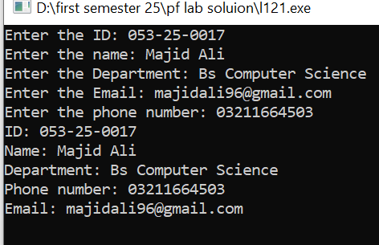
cout<<"ID: "<<p.ID<<endl;
cout<<"Name: "<<p.name<<endl;
cout<<"Department: "<<p.depart<<endl;
cout<<"Phone number: "<<p.phonenumber<<endl;
cout<<"Email: "<<p.email<<endl;

return 0;
}

Q 2:
Write a C++ program to do: a) Create a structure/record to store products; each product has a name, a model number and a price. b) Choose appropriate types for these fields/attributes. c) Your program should contain a loop which allows entry via the keyboard of up to 10 products, and stores them in an array d) Finally, the program should include a function to display all the products details after the entry loop has finished.
#include <iostream>
#include<iomanip>
using namespace std;
struct product {
string name;
int model;
float price;
};
void productdisplay(product p1[10]){
cout<<"------------------------------------------------\n" ;
cout<<left<<setw(20)<<"Name"<<setw(10)<<"Model"<<setw(20)<<"Price"<<endl;
for(int i=0; i<10; i++){

cout<<left<<setw(20)<<p1[i].name<<setw(10)<<p1[i].model<<setw(24)<<p1[i].price<<endl;
}
cout<<"-------------------------------------------------\n" ;
}
int main(){
product p1[10];
for(int i=0; i<10;i++){
cout<<"Enter the product "<<i+1<<": "<<endl;
cout<<"Enter the product name: ";
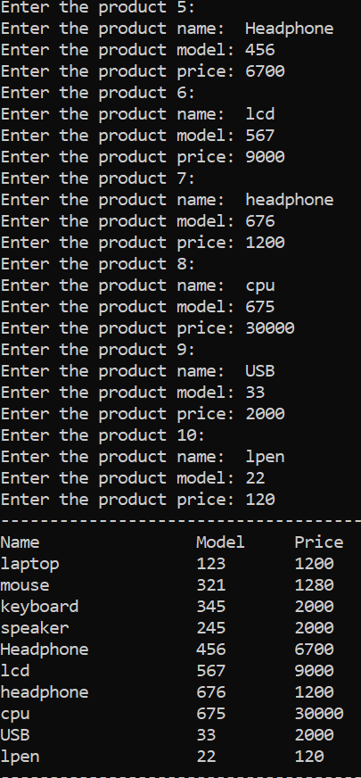
fflush(stdin);
cin>>p1[i].name;
cout<<"Enter the product model: ";
cin>>p1[i].model;
cout<<"Enter the product price: ";
cin>>p1[i].price;
}
productdisplay(p1);
return 0;
}

Q 3:
Write a C++ program that compute Net Salary of Employee. Program should contain two user defined functions empSalary( ) and display( ). a) Create a structure of Employee that contains following data members: i. EmployeeNumber, Name, BasicSalary, HouseAllowance, MedicalAllowance, Tax, GrossPay and NetSalary b) EmployeeNumber, Name, and BasicSalary should be taken input from the user c) The function empSalary( ) should compute the Employee salary with given criteria i. HouseAllowence = 10% of BasicSalary ii. Medical Allowence = 5% of Basic Salary iii. Tax = 4 % of Basic Salary iv. GrossSalary = Basic+HouseAllowence+MedicalAllowence v. NetSalary = GrossSalary – Tax d) The function display() should display the details of Employee, like shown below:
#include <iostream>

using namespace std;

struct employ {
float EmployeeNumber, BasicSalary, HouseAllowance,
MedicalAllowance, GrossPay, NetSalary, Tax;
string name;
};

void empsalary(employ &employinformation) {
cout << "Enter the employ number: ";
cin >> employinformation.EmployeeNumber;
cin.ignore();

cout << "Enter the employ name: ";
getline(cin, employinformation.name);

cout << "Enter the basic salary: ";
cin >> employinformation.BasicSalary;

employinformation.HouseAllowance = 0.10 * employinformation.BasicSalary;
employinformation.MedicalAllowance = 0.05 * employinformation.BasicSalary;
employinformation.Tax = 0.04 * employinformation.BasicSalary;
employinformation.GrossPay = employinformation.BasicSalary +
employinformation.HouseAllowance +
employinformation.MedicalAllowance;
employinformation.NetSalary = employinformation.GrossPay - employinformation.Tax;
}

void display(employ employinformation) {

cout << "Employ number: " << employinformation.EmployeeNumber << endl;
cout << "Employ name: " << employinformation.name << endl;
cout << "Basic salary: " << employinformation.BasicSalary << endl;
cout << "House allowance: " << employinformation.HouseAllowance << endl;
cout << "Medical allowance: " << employinformation.MedicalAllowance << endl;
cout << "Tax: " << employinformation.Tax << endl;
cout << "Gross pay: " << employinformation.GrossPay << endl;
cout << "Net salary: " << employinformation.NetSalary << endl;
}
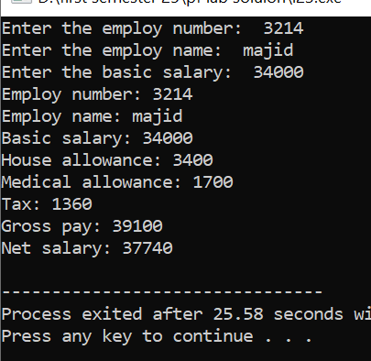
int main() {
employ employinformation;

empsalary(employinformation);
display(employinformation);

return 0;
}
Q 4:
Consider the following code: #include #include using namespace std; struct Student { string name; int id; int mark[3]; }; void inputStudent(Student* ptr); //function prototype for getting input // some other function for printing the details //*********************** Main Function ************************// int main () { Student stu; // declaring an Student object Student* stuPtr = &stu; // defining a pointer for the object inputStudent(&stu); // calling function to get input into the object // calling the other function to print the details of the object return 0; } // end main DEPARTMENT OF COMPUTER SCIENCE, SUKKUR IBA UNIVERSITY 11 PREPARED BY: ENGR. ZAINAB UMAIR
In above given code there is a prototype, and a call to a function to input the values into a Student instance. Note that the parameter to this function is the address of a structure instance. a) Write the definition for this function at the bottom of the file. b) Then, write a function that takes a pointer to an instance of the Student structure and displays the contents
#include <iostream>
#include <string>
using namespace std;
struct Student {
string name;
string id;
int mark[3];
};
void inputStudent(Student* ptr);
void displayStudent(Student* ptr);
int main() {
Student stu;
Student* stuPtr = &stu;
inputStudent(stuPtr);
displayStudent(stuPtr);

return 0;
}
void inputStudent(Student* ptr) {
cout << "Enter student's name: ";
cin.ignore();
getline(cin, ptr->name);
cout << "Enter student's ID: ";
cin.ignore();
cin >> ptr->id;
for (int i = 0; i < 3; i++) {
cout << "Enter mark " << i + 1 << ": ";
cin >> ptr->mark[i];
}
}
void displayStudent(Student* ptr) {
cout << "\nStudent Details:\n";
cout << "Name: " << ptr->name << endl;
cout << "ID: " << ptr->id << endl;

for (int i = 0; i < 3; i++) {
cout << "Mark " << i + 1 << ": " << ptr->mark[i] << endl;
}
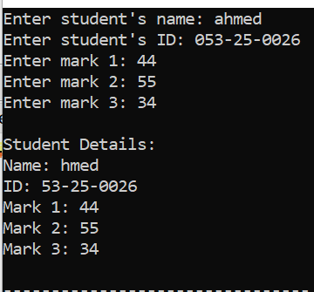
}

Q 5:
Making and Using Dynamically Allocated Arrays. Let us say that you want to choose how many marks to enter for the student and have the array change size accordingly. This gives you the opportunity to work with dynamic pointers. You will have to make the following changes to the code previously given: a) Change mark within the Student struct to an integer pointer. b) Ask the user from main how many marks he/she would like to enter c) Change both the functions to have an additional parameter which is the number of marks. d) For the inputStudent function, dynamically allocate the marks according to the number required.
#include <iostream>
#include <string>
using namespace std;
struct Student {
string name;
string id;
int* mark;
};
void inputStudent(Student* ptr, int numMarks);
void displayStudent(Student* ptr, int numMarks);
int main() {
Student stu;
Student* stuPtr = &stu;
int numMarks;
cout << "How many marks do you want to enter? ";
cin >> numMarks;
inputStudent(stuPtr, numMarks);
displayStudent(stuPtr, numMarks);
delete[] stu.mark;
return 0;
}
void inputStudent(Student* ptr, int numMarks) {
cout << "Enter student's name: ";
cin.ignore();
getline(cin, ptr->name);
cout << "Enter student's ID: ";
cin >> ptr->id;
ptr->mark = new int[numMarks];
for (int i = 0; i < numMarks; i++) {
cout << "Enter mark " << i + 1 << ": ";
cin >> ptr->mark[i];
}
}

void displayStudent(Student* ptr, int numMarks) {
cout << "\nStudent Details:\n";
cout << "Name: " << ptr->name << endl;
cout << "ID: " << ptr->id << endl;

for (int i = 0; i < numMarks; i++) {
cout << "Mark " << i + 1 << ": " << ptr->mark[i] << endl;
}



